1.Draw and label diagrams of star, bus, and mesh network topologies on paper or using any drawing tool. For each, write one real-world app or service (like WhatsApp, Flipkart, or IPL streaming) that could use that topology and explain why in 1-2 lines.

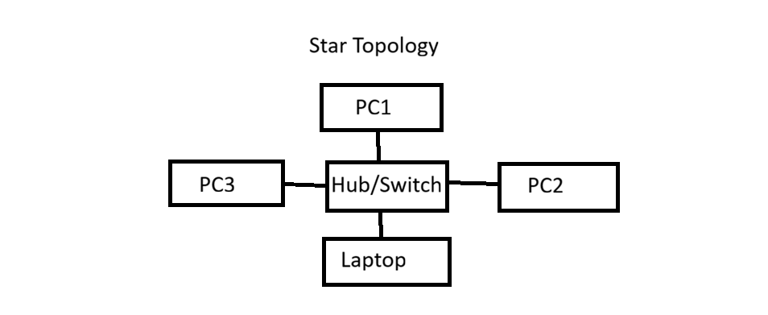
Example: Flipkart
Reason: All users connect to a central server.
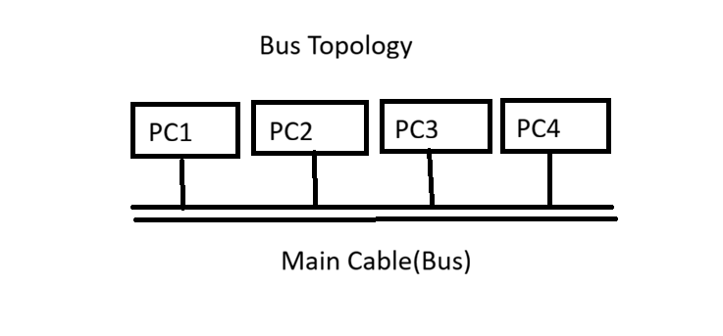
Example: College Computer Lab
Reason: All computers share one main cable.

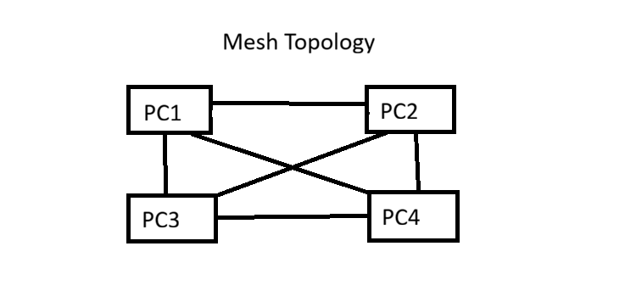
Example: IPL Live Streaming
Reason: Multiple paths keep the network working even if one connection fails.

2.Create a comparison table listing at least four pros and four cons for each of these topologies: star, bus, ring, mesh. Include a column for 'Best Use Case' and give an example from apps you use (e.g., Instagram, Zomato, Paytm).

Topology | Pros (Advantages) | Cons (Disadvantages)
Star | 1. Easy to install.2. Easy to manage.3. One device failure does not affect others.4. Easy to find faults. | 1. Needs more cable.2. Hub/Switch failure stops the network.3. Cost is higher.4. Depends on central device.
Bus | 1. Low cost.2. Easy to set up.3. Uses less cable.4. Good for small networks. | 1. Main cable failure stops the network.2. Slow with many devices.3. Difficult to troubleshoot.4. Limited cable length.
Ring | 1. Data moves in order.2. No data collision.3. Equal access for all devices.4. Good performance with medium traffic. | 1. One device failure affects the network.2. Difficult to add devices.3. Troubleshooting is difficult.4. Maintenance is costly.
Mesh | 1. Very reliable.2. Multiple communication paths.3. High security.4. No single point of failure. | 1. Expensive.2. Needs many cables.3. Difficult to install.4. Complex maintenance.
5 | Smartwatch | PAN (Bluetooth), LAN (WiFi)

3.Imagine you are designing a new multiplayer mobile game like PUBG or Free Fire. Choose a suitable network topology for the game servers and justify your choice in 3-4 lines, mentioning how it would impact speed, reliability, and cost.

->Suitable Network Topology: Star Topology
I would choose Star Topology for a multiplayer game like PUBG or Free Fire.
It provides fast communication because all players connect to a central game server.
It is reliable, as if one player's connection fails, other players can continue playing.
The cost is medium because it requires a central server, but it is easy to manage and maintain.
4.Given this scenario: A small Flipkart-style warehouse wants to connect 8 computers for order processing and inventory updates. Recommend a network topology, sketch a quick diagram, and explain your reasoning in 2-3 lines.<br><br><em><strong>Hint:</strong> Consider factors like cost, ease of troubleshooting, and future expansion.</em>

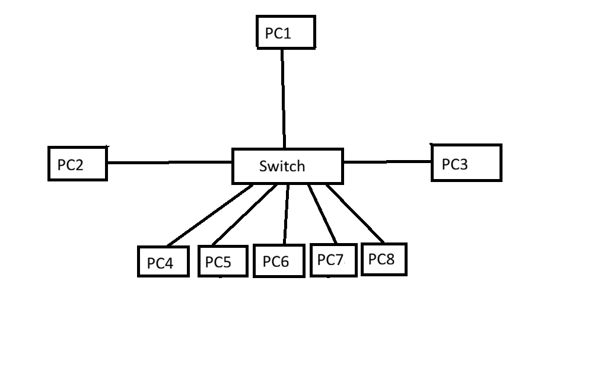

Reason:
I recommend Star Topology for the warehouse.
It is easy to install and troubleshoot. If one computer fails, the other computers continue to work. It is also easy to add more computers in the future.

